mVitals - An Intelligent Edge Computing Based Wireless Mobile Healthcare System

Session 2017-2021A 4th Year Student

4th Year Student

A project submitted in partial fulfilment

Of

BSc. (Hons.)BS in Computer Science (CUI)



Department of Computer Science

COMSATS University Islamabad, Lahore Campus

01 March 2020

**Project Registration**

|  |  |  |  |  |  |  |  |
| --- | --- | --- | --- | --- | --- | --- | --- |
| Project ID (for office use) | | |  | | | | |
| Type (Nature of project) | | | [ ] **D**evelopment [ ] **R**esearch [*] **R**&**D** | | | | |
| Area of specialization | | |  | | | | |
| **Project Group Members** | | | | | | | |
| Sr.# | Reg. # | Student Name | | CGPA | Email ID | Phone # | Signature |
| (i) | SP17-BCS-029 | Noor Jaffri | | 2.69 | sp17-bcs-029@cuilahore.edu.pk | 0301-4576412 |  |
| (ii) | SP17-BCS-080 | Hafsa Khan | | 2.69 | sp17-bcs-080@cuilahore.edu.pk | 0342-0610751 |  |
| (iii) | SP17-BCS-101 | Muhammad Irtiza | | 2.57 | sp17-bcs-101@cuilahore.edu.pk | 0309-0047457 |  |
| Name & Signature of Batch Advisor  (If students are eligible for FYP) | | | | Zaheer Gondal | | | |

# Plagiarism Free Certificate

This is to certify that, I am Noor Jaffri S/D/o Syed Hamid Hussain Jaffri, group leader of FYP under registration no CIITSP17-BCS-029/LHR at Computer Science Department, COMSATS Institute of Information Technology, Lahore. I declare that my FYP proposal is checked by my supervisor and the similarity index is ________% that is less than 20%, an acceptable limit by HEC. Report is attached herewith as Appendix A.

Date: ____________ Name of Group Leader: Noor Jaffri Signature: _____________

Name of Supervisor: Imran Raza Co-Supervisor (if any):____________________

Designation: Assistant Professor Designation: _____________________

Signature: _____________________ Signature: _____________________

**Approval of FYP Management Committee**

Committee Member 1: Name: _____________________

[ ] Accept [ ] *Defer [ ] *Reject Signature: _______________

*Remarks: _____________________________________________________________________

Committee Member 2: Name: _____________________

[ ] Accept [ ] *Defer [ ] *Reject Signature: _______________

*Remarks: _____________________________________________________________________

Convener: Name: _____________________

[ ] Accept [ ] *Defer [ ] *Reject Signature: _______________

*Remarks: _____________________________________________________________________

**Project Abstract**

Internet of Things (IoT) made it possible to interconnect millions or billions of different “Things” to create huge networks. IoT based applications include but not limited to smart homes, automated parking systems, fitness bands and health monitoring systems etc. Autonomous and effective real-time health care monitoring systems are also blessing of IoT. Internet of Things (IoT) allows effective and flexible real-time health care monitoring systems, equipped with sensors which collect the patient’s data regarding vital signs and reduce human error. The existing systems use cloud computing technology where the collected data is stored, processed and analysed on cloud servers. As the human population has been increasing exponentially, public healthcare sector is focusing on the advanced wearable devices rather than traditional monitoring systems. Due to lack of continuous monitoring, many patients have been suffering in hospitals as well as in homes. To overcome this problem, technical experts are discovering new and viable approaches based on various technologies e.g. cloud, edge and fog computing. The proposed intelligent system i.e. mVitals, targets such patients who require real-time healthcare monitoring. It will provide an advance wearable system, based on edge computing, that will highly portable and easy to use. The key objective of mVitals is to monitor the patients’ vital signs such as heart rate, electrocardiogram (ECG), body temperature, etc. on real-time. The communication of the system will be based on wireless technology, so the patient wearing it will not feel tangled with wires. mVitals will be designed using Arduino Nano and various sensors such as, ECG Module, heart rate, body temperature, blood pressure and breathing rate sensor. The patient’s data will be acquired via sensors and transferred to an edge server where deep learning algorithms are applied for analytics and predictions. Medical history and reports of the patients will be stored in a real-time database which will further help doctors to assess the patient’s condition and suggest treatment plans based on deep learning. Healthcare is not only the most promising application of IoT technology, but also these devices and systems have the potential to enhance the quality of patients’ monitoring.

**Table of Contents**

1 Introduction 7

2 Motivation and Scope 8

3 Related Work 8

4 System Architecture 10

4.1 Wireless Sensor Environment 10

4.2 Real-time sensor Data Acquisition 11

4.3 Edge Server Networking 11

4.4 Cloud Storage 11

4.5 End-User Interface 11

5 Goals and Objectives 11

5.1 Main Goals 12

5.2 Objectives 12

6 Individual Tasks 12

7 Gantt Chart 14

8 Future Work 14

9 Tools and Technologies 14

9.1 Languages 14

9.2 Tools 15

10 Conclusion 15

11 References: 16

**List of Figures**

Figure 1 – ViSi Mobile’s Hardware. 9

Figure 2 - System Architecture 10

Figure 3 - Gantt chart 13

# Introduction

The Internet of Things (IoT) has made a great evolution over the years [1]. It is a system of devices, some with built-in sensors, connected through the internet that collects data and apply analytics to extract valuable information. This information can be used to detect patterns, provide recommendations, and suggest future actions etc. Today, applications of IoT systems can be observed in every domain especially in healthcare for remote monitoring of patients, even in real-time. The focus is not only to monitor vital signs and electrocardiogram (ECG) but the healthcare industry is working on telehealth, smart hospitals, hearables, etc. Most IoT systems are based on cloud-computing technology, which provides data storage, privacy, easily manageable data, and unified access. Furthermore, because of IoT contributions in healthcare, Internet of Medical Things (IoMT) has become a branch of IoT because of IoT contributions in healthcare [2].

The Internet of Things is bringing the healthcare industry a new life. One of the best ways is where the doctors can use the appropriate digital patient information to take suitable decisions. It increases the quality of patient information in the medical field. mVitals will use edge computing in combination with intelligent IoT devices. This will allow the system to collect on-patient data, send it to their local clinic and provide medical staff with real-time information. Patient data could be checked even if the patient is not present and has not made an appointment. This system will use different sensors like ECG, heart rate, body temperature, blood pressure and breathing rate sensor to monitor patient’s health. These sensors will be attached to a microcontroller like Arduino. To monitor a patient's health, caretaker will use an end user device to screen the vitals, which would be connected to an edge server wirelessly.

IoT systems use several architectural approaches. Most IoT systems are based on cloud-computing technology, which provides data storage, privacy, easily manageable data, and unified access. Cloud computing method is dependent on internet that allow computers and other equipment to share software and hardware information [3].

However, because of the high costs and complexity in centralized systems IoT devices are adapting edge computing. IoMT is also acclimating to edge computing [4] over current centralized cloud infrastructure, because of increase demand of data driven care in health industry. Edge computing is a decentralized architecture deployed in proximity of the user to reduce latency and bandwidth utilization. It is more secure, efficient, inexpensive, and scalable; it also provides local manipulation of data [5]. Furthermore, in health care monitoring system, the functionality can be very crucial for the patient in case of low bandwidth rate. Edge computing solves this problem and is beneficial for the applications that require intensive computations and low latency. Besides low latency, edge computing is preferred over cloud in remote locations as well, where there is limited or no connection to a central server location.

mVitals will use edge-computing architecture in a health monitoring IoT system. Proposed solution splits the problem into three manageable pieces. A decentralized edge architecture, where IoT will gather data. Gathered data is sent to cloud where analytic processes and communications happens, and data is stored short term. Lastly a data center where data is stored long term and will be filtered and analysed. It will use deep learning algorithms, which learn from the past data of patients and provide predictions about the critical condition of patients. Deep feature learning will use patient data from Electronic Health Record (EHR) and facilitates the system with predictive modelling. A set of general features, which are inferred automatically from a large-scale EHR database through a deep learning approach. Features will be processed with EHRs to captured stable structures and regular patterns in the data, which, grouped together, compose the deep patient representation and predictions of possible diagnosis.  Medical history and reports of the patients will be stored in a real-time database, which will further help doctors to access the patient’s condition and suggest treatment plans based on the deep learning.

# Motivation and Scope

* Most of the current healthcare monitoring systems have jumbled up hardware. In order to tackle this problem, most of the functionalities performed by our system use wireless technology, such as cellular networks, Wi-Fi and Bluetooth.
* According to [7], due to insufficient equipment in hospitals for emergency conditions, patients suffer, and lives are at stake. To overcome this problem, an intelligent healthcare monitoring system is introduced, which continuously monitors the vital signs and ECG of patients through wirelessly connected devices.
* Transfer delay of trauma patients to hospitals, leads to complications and suffering [8]. Even seconds can make a difference. This was the motivation to introduce such a system that even a non-medical person could use to monitor vital signs and alert hospitals on time in case of any criticality.
* As the Electronic Health Records (EHRs) [9] are replacing paper records, the proposed system will store the patients’ data in an online-secured database. This allows the authorized personnel to access the records anytime and anywhere.
* This system monitors vital signs and ECG of the patient remotely. Hence, reducing the effort of doctors and patients.
* This smart medical monitoring and diagnostic system will not only be utilized in hospitals, ambulances, etc. but also collaborate with the smart home idea to make it part of daily life activities.
* The system will use deep learning algorithms, which learn from past data of patients. It provides predictions about the critical condition of patients.

# Related Work

As the health industry begins to incorporate IoT devices and systems, many wired or unwired gadgets and armbands are developed to monitor patients’ health in real-time. However, they are either not very versatile or efficient. A fitness tracking smartwatch is introduced in [10] that collects and displays users’ heart rate, steps in a day and calories burnt. However, it has only limited sensors and does not monitor all the vital signs such as oxygen level and respiratory rate. Thus, the scope of its health care monitoring functionality is limited.

A pulse oximeter is developed in [11] to determine the arterial oxygen saturation in the blood of the user, and heart rate during sports at high altitudes, etc. However, it also serves a single function and is a delicate device.

An e-Health system was developed in [12] to measure blood pressure, heart rate, electrocardiogram (ECG) & temperature. Afterward, the information is forwarded to an android application for analysis. However, this system uses only Bluetooth for communication among connected devices, which is not a long-range medium and has low bandwidth.

An Australian team has developed a gadget that can monitor blood pressure continuously [13]. It does not require uncomfortable cuffs on the arms to function; rather it is very easy to use the device. However, its accuracy drops to 83% during exercise.

Sotera Wireless Inc. developed a small and portable multipurpose device called ViSi Mobile [14]. It is capable of monitoring patients’ heart rate, blood pressure, pulse rate, respiration rate, skin temperature, etc. in [Figure 1]. The major drawbacks of this device are that it is very expensive and usually works on cellular networks, which can be unavailable in some regions. However, some of the newer and expensive versions can also be connected via Wi-Fi. Figure 1 shows hardware connectivity of ViSi Mobile with a human body, which has plenty of wires that could be irritating for the patient.

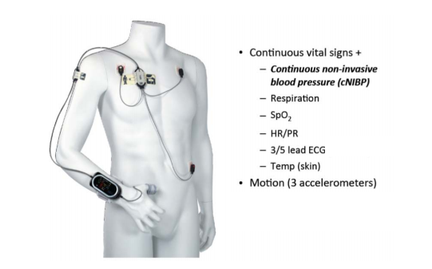

**Figure 1 – ViSi Mobile’s Hardware [15]**.

# System Architecture

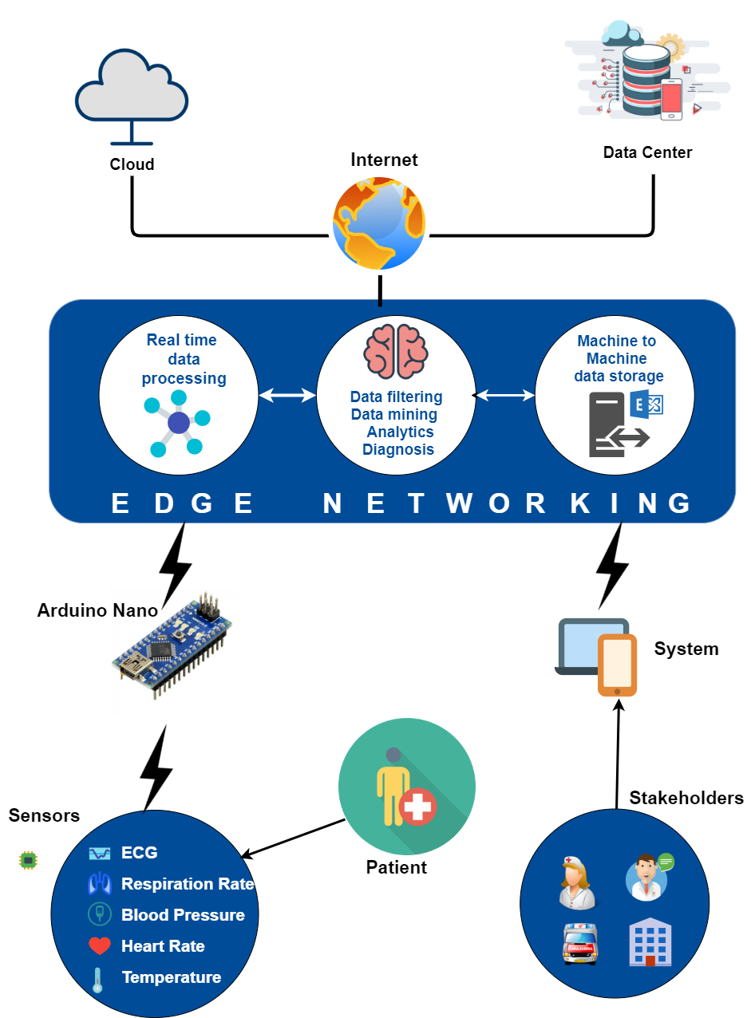

Figure 2 - System Architecture

The architecture for mVitals is shown in Figure 2. The basic components of the architecture are discussed as follows:

## Wireless Sensor Environment

All the sensors will be encapsulated inside a wireless device and this device will wirelessly connect with the system via a microcontroller. The patient will only need to wear the device and the sensors will automatically start collecting the data. As the device will be portable, patients will allow to roam freely in the network.

## Real-time sensor Data Acquisition

The vital signs sensors will record the patient’s physiologic parameters using ECG Module (AD8232), heart rate sensor XD-58C, body temperature sensor LM-35, blood pressure sensor CPS120 and breathing rate sensor ADS1292R on real-time with the help of microcontroller i.e. Arduino Nano. Filtration will be applied on this acquired data to remove noise and then transfer it to the cloud via edge server i.e. Raspberry Pi.

## Edge Server Networking

Edge server is the most important component of our monitoring system. Raspberry Pi will be used as edge server. Raspberry Pi fetches the data from microcontroller and applies deep learning techniques, with the incorporation of CDSS, on the sensory data. Complete filtration is applied on acquired data to remove noise. If the values of filtered data are abnormal, the alert messages and notifications are sent to the caretakers and medical staff on end-user devices e.g. mobile phone, laptop etc.

## Cloud Storage

Long-time data processing and storage will be performed with the help of cloud services. The acquired values of all individual parameters from edge server will be save on the cloud separately. The cloud data is secured so that only authorized users could access patient’s information. Unlike the traditional databases, this information will be accessed instantly anywhere with high processing power. Long-time data processing and storage.

## End-User Interface

An interactive, efficient and adaptive interface will be provided to the end-users. The end-users i.e. caretakers and medical staff will be able to monitor patients’ vital signs on android application as well as on a web application. All the extracted features will be displayed on the applications in real-time. The visualization of fluctuation in the data readings will be performed using graphs so that the user can receive the best possible observation and monitoring. In the case of emergency, mVitals will generate notifications and alert that will be occurred on end-users’ devices.

# Goals and Objectives

An intelligent and innovative healthcare monitoring system for the patients to monitor them on the real-time, for the improvement of the diagnosis with the help of edge computing technology.

## Main Goals

* Our main goal is real-time health monitoring for the patients of general healthcare settings.
* The aim is to build a comfortable and portable monitoring system by reducing the wire entanglement.
* A cost effective and efficient system, which will provide visual representation of patient’s real-time data.
* A smart system using deep learning algorithms for patients’ diagnosis and can assist doctors in case of emergency.
* A system will which can work wirelessly and get the signals from other devices.

## Objectives

* Design and implement an intelligent as well as a portable system for real-time healthcare monitoring.
* Develop a smart medical monitoring system, that will not only be utilized in hospitals, ambulances, etc. but also collaborate with the smart home idea to make it part of daily life activities.
* Deploy deep learning techniques for training and testing for models, to provide reliable disease diagnosis.
* Design a system incorporating a Clinical Decision Support System (CDSS), which will enhance the patient’s diagnosis with better analytics.
* Assist the doctors/caretakers to monitor the patient and provide a reliable notification mechanism in case of any critically.
* Make use of wireless technology, to get rid of jumbled up wired hardware systems and allowing patients to roam freely.
* Develop an edge computing based system backed up with the cloud services, to provide storage and analysis of data in real time.
* Store and manage the health record of the patients for different purposes.
* Provide adequate visual representation of patient’s vital signs and ECG, so even a non-medical person can monitor the patient.
* Reduce the costs associated with employing expensive monitoring equipment.

# Individual Tasks

In this part, Table 1 indicates the distribution of tasks between the members of the group.

|  |  |  |
| --- | --- | --- |
| **Group Members** | **Registration ID** | **Tasks** |
| NOOR JAFFRI | SP17-BCS-029 | * Writing Proposal * Research and Literature Survey * Designing System Architecture * Integrating Hardware/Sensors * System Development and Debugging * Networking and Integration * Tasks' Evaluation |
| HAFSA KHAN | SP17-BCS-080 | * Writing Proposal * Research and Literature Survey * Designing System Architecture * System Development * Database Designing and Management * Modelling of System * Reports Generation |
| MUHAMMAD IRTIZA | SP17-BCS-101 | * Writing Proposal * Research and Literature Survey * System Development * Build User Interface * Testing User Interface * Handling Hardware * Documentation |

**Table 1- Tasks**

# Gantt Chart

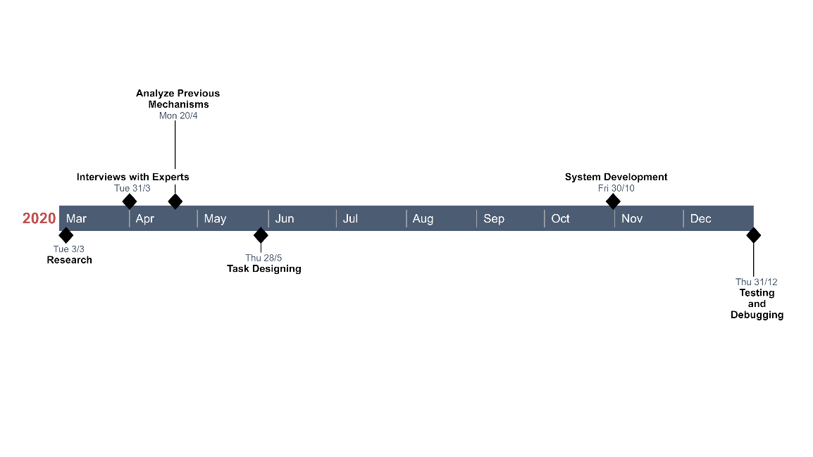

Figure 3 - Gantt chart

# Future Work

* More sensors such as diabetes sensor, Electrocardiography (ECG) with 12 leads (limb and precordium leads), etc. will be installed on the system for more accuracy and detailed monitoring.
* mVitals with implementation of VR technology and adaptation for Microsoft HoloLens.
* The system can be installed in the hospitals of the entire city, which will be connected to a centralized server for more experienced monitoring.
* In future, the system can be incorporate with the smart medication system for the right dose.

# Tools and Technologies

## Languages

* C/C++
* Java
* JavaScript
* Python

## Tools

* Raspberry Pi
* React
* Node
* Wi-Fi Router
* Arduino IDE
* ECG Module (AD8232)
* ECG Electrodes
* ECG Electrode Connector
* ASD1292R Respiration Shield
* Arduino Nano (ATmega328P)
* Heart rate sensor XD-58C
* Body temperature sensor LM-35
* Blood pressure sensor CPS120
* Breathing rate sensor ADS1292R

# Conclusion

The proposed system will be mobile and wearable enabling wireless communication to continuously monitor vital signs and ECG of a patient. The system will store records of patients’ history as well as real-time monitoring data for future reference. The purpose was to present a design of middleware platform to support better data acquisition operations in mobile health care monitoring environments. The data will be stored in a secure and efficient database system and only authorized people will have the remote accessibility of a patient’s medical records, regardless of whereabouts with high processing speed. Incorporation of Clinical Decision Support System (CDSS) will enhance the patient’s diagnosis and provide better analytics using deep learning techniques. The system will aid in devising treatment plans for patients based on deep learning and past data. This cost effective and efficient system will represent data in an easy to understand manner. Alerts and notifications will be sent to the concerned personnel in case of any critical change in health parameters of patients so that the patient never stays unobserved. The aim is to improve the quality of life related to health care, with the help of continuous monitoring. The health care takers can screen, analyse and diagnose their patients constantly. The proposed system uses machine-learning algorithms to analyse past data, to improve healthcare by predictions and better analytics. It will not only be available in the hospitals and ambulances but will also be integrated with the smart home systems.

# References:

[1] J. Chase, “The evolution of the internet of things,” *Texas Instruments*, vol. 1, pp. 1–7, 2013.

[2] Ankur Limaye and Tosiron Adegbija, “A Workload Characterization for the Internet of Medical Things IoMT”, *IEEE Computer Society Annual Symposium on VLSI (ISVLSI)*, pp. 1-6, 2017.

[3] “6 IoT in Healthcare Examples That’ll Make You Feel Better |Built In” from [https://builtin.com/internet-things/IoT-in-healthcare](https://builtin.com/internet-things/iot-in-healthcare) , accessed on 5 February 2020.

[4] “Moving from central to the edge: Is cloud decentralization inevitable?” from <https://www.information-age.com/cloud-decentralisation-inevitable-123472539/> , accessed on 5 February 2020.

[5] “Volume 8, Number 2, Jan 2013”, from <https://dl.acm.org/doi/abs/10.1145/3012000>, Article No.: 70, December 2016.

[6] “Fog Computing and the Internet of Things: Extend the Cloud to Where the Things Are”, from <https://www.cisco.com/c/dam/en_us/solutions/trends/iot/docs/computing-overview.pdf> accessed 18 February 2020.

[7] [B.P.McNicholl](https://www.sciencedirect.com/science/article/abs/pii/0020138394900736#!), “The golden hour and prehospital trauma care”, from <https://doi.org/10.1016/0020-1383(94)90073-6>, [Volume 25, Issue 4](https://www.sciencedirect.com/science/journal/00201383/25/4), May 1994, Pages 251-254

[8] “Delays in reaching hospitals contribute to high trauma deaths” from <https://www.thenews.com.pk/print/85963-Delays-in-reaching-hospitals-contribute-to-high-trauma-deaths>, Mon Feb 17 2020.

[9] Bianca Banowa, “The Impact of Technology in Healthcare” from <https://www.aimseducation.edu/blog/the-impact-of-technology-on-healthcare/>, June 2, 2019.

[10] “F8 Smartwatch Weather Forecast Fitness Tracker” from https://www.alibaba.com/product-detail/F8-Smartwatch-Weather-Forecast-Fitness-Tracker_62235386764.html?spm=a2700.galleryofferlist.0.0.4ffe3fe9AHkc5Q**,** accessed on February 26, 2020.

[11] “Beurer Po 30 Pulse Oximeter” from <https://www.beurer.com/web/gb/products/medical/ecg-and-pulse-oximeter/pulse-oximeter/po-30.php> , accessed on 5 February 2020.

[12] "Smart Health Care Monitoring System Based on IoT" from <https://create.arduino.cc/projecthub/156471/smart-health-care-monitoring-system-based-on-iot-f559b3> , accessed on 12 February 2020.

[13] “Wearable Monitor Blood Pressure” from <https://www.medgadget.com/2020/01/wearable-monitor-provides-continuous-blood-pressure-data.html>, accessed on 5 February 2020.

[14] “Sotera Wireless – ViSi Mobile” from <https://www.youtube.com/watch?v=WF8UGt3IipY>, accessed on 6 February 2020.

[15] Johnny Kaye T’12 and Professors Ron Adner and M. Eric Johnson, “Sotera Wireless”, from <https://digitalstrategies.tuck.dartmouth.edu/wpcontent/uploads/2016/10/Sotera_Wireless_6-0035.pdf> , 4 September 2012, Page 6.

*Include here the 1st page of Turnitin Report*

Every supervisor has his/her own Turnitin account. If not then supervisors are requested to get the account from Library as soon as possible.